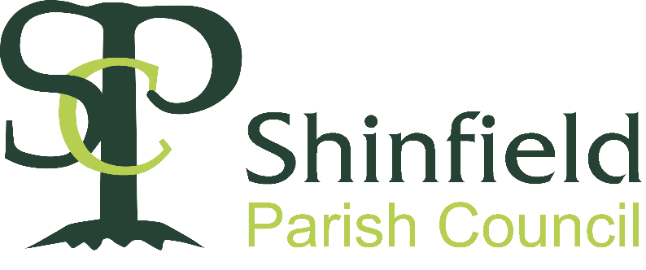
Shinfield Parish Council
Artists’ Criteria
Shinfield School Green Centre

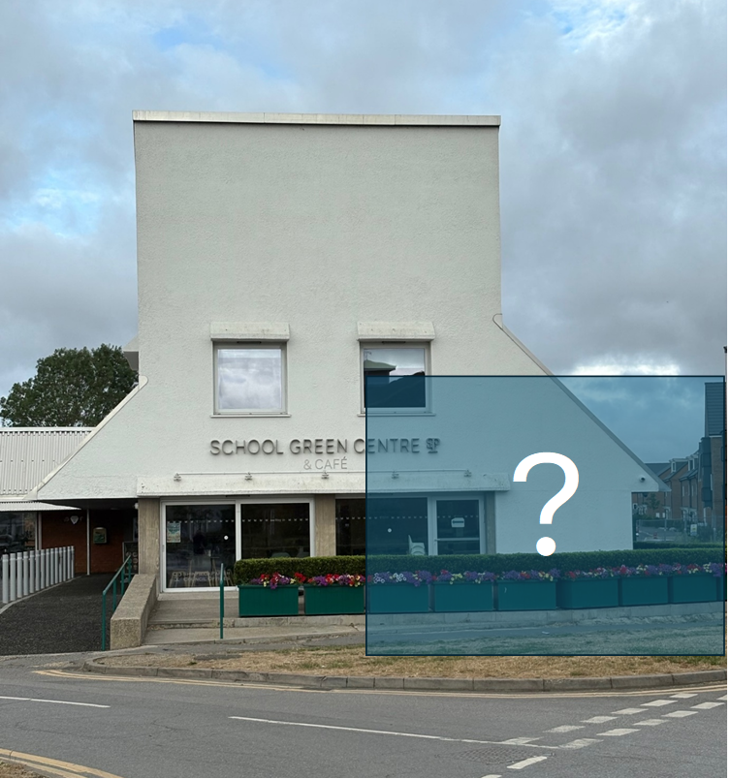

Stage 1 – Expressions of Interest
- The work must be the artist’s own original design. AI should not be used to generate proposals.
- The artist must have a proven track record, including delivering art projects for the public realm on time and on budget.
- The artist must provide a comprehensive CV and two recent written references from your work in the public realm.
- The artist will need to demonstrate that they can manage the project from design, through to installation, pulling in all of the necessary expertise along the way.
- Submitted designs must be able to stimulate engagement with the community.
- Submitted designs will need to consider how the final work will relate to the surrounding buildings (materials, scale, form etc.), softer landscaping and people using the space.
  - In particular, artists should consider how the final work serves to activate or enhance the public space.

- It is the vision that the final work will be a major landmark for the parish of Shinfield which fosters a sense of wellbeing.
- The artist must demonstrate how local research has produced a meaningful and relevant design.
  - Whilst submitted designs should be relevant to the parish of Shinfield and its people, culture and values, this does not imply a restriction to the historical, may look towards the future of the parish or be a design which bridges between the past and future.
- The artist will need to demonstrate how they will consider reducing the carbon footprint of their proposed work.
  - This can include the use of different materials, manufacturing and transport etc. In consideration of lighting or the kinetics of a work, the artist may consider wind or solar energy if practicable.

- The design could have a structural function (for example seating).
- The artist must be able to demonstrate a realistic project timetable (from design to delivery) and budget, illustrating that they have considered all of the possible constraints and risks associated with a project of this scale.
- Shinfield Parish Council is committed to diversity and equality and would like to encourage artists and works that draw upon and reflect the full range of backgrounds and perspectives to be found in our society.

We will consider proposals from artists working as a team in collaboration, but the budget will remain the same.

Expressions of Interest should be directed to spa@shinfieldparish.gov.uk and received by 24th October 2025.

Judges’ decisions are final.

Stage 2 – After shortlisting

- Shortlisted artists will be paid £250 to work up further iterations of their three site specific designs.
- The shortlisted artists must demonstrate how local research has produced a meaningful design with a relevant story within the design.
- Proposals should include details regarding
  - fabrication, installation requirement and maintenance.
- Shortlisted Artists must demonstrate how they have considered any limitations or constraints of the site or project including local planning policy in working up their designs.
- Shinfield Parish Council is committed to fair and ethical sourcing. Therefore, all shortlisted artists must be able to demonstrate if required that they are able to conduct their affairs and acquire goods and services for this project without causing harm to others.
- As the final work will be positioned in the public realm, it may be the subject of vandalism. Therefore, shortlisted artists must demonstrate that materials, forms and structures will be robust and are easy and low cost to maintain.
- Shinfield Parish Council’s Commissioning Panel reserve the right to not accept any of the submissions.

Judges’ decisions are final.

Stage 3 Finalist
- After evaluation of the shortlisted proposals by the Commissioning Panel the finalist will be announced and advanced a concept fee of £5,000 towards costs including the final proposal.
- The artist will need to carry out consultation with the community including outreach and site visit(s) (schools, talks to local interest groups, promoting the concept and publicising the work)
- The final proposal will include:
  - Location plans
  - Detailed visualisation of the work which can be used for on-going consultation and fundraising
  - A maquette or model (if appropriate)
    - Any such maquette or model will become the property Shinfield Parish Council and on request the copyright in the same will be assigned
  - If the artists provides any CGI copyright in the same, on request, will be assigned to Shinfield Parish Council
  - A written statement outlining their ideas, research and key references associated with the work
  - Methodology for production and fabrications demonstrating how they have considered any limitations or constraints of the site or project in working up their designs
  - Cost budget (and cashflow)
  - Timeline / Gantt Chart
  - Considerations of maintenance and long-term sustainability of the proposed work
- The Commissioning Panel reserve the right to not accept the final submission.
- The successful artist will need to submit and get their work approved by Wokingham Borough Council’s Planning Committee, therefore they must be able to provide the necessary documentation and visual materials required for a planning application.
- The successful artist is expected to attend the relevant planning committee at Wokingham Borough Council (unless agreed otherwise by Shinfield Parish Council) when this application is considered by the Planning Committee.
- The artist or their representative must be able to commit to attending project planning meetings on a regular basis from being awarded the project.
- The successful artist or their representative must also be able to assist the committee by attending meetings, where possible, with local businesses in order to aid the fundraising by helping to explain the concept for the artwork. These will be limited to online meetings where possible.
  - However, reasonable travel expenses will be reimbursed if an in-person meeting is necessary and on receipt of invoices/receipts.

Shinfield Parish Council is a council at the lowest tier of local government in England. Wokingham Borough Council forms the next level and has responsibility for planning decisions

